**Takeaway Restaurant Management System**

Problem Statement -

A lot of transactions take place in a take-away restaurant each day. Recording them and all associated tasks of operating a restaurant like managing inventory, managing employee data and analysing the data can be a tedious task if done manually in record books. As an alternative, one can accomplish all these tasks in a single system using a database management system.

This system should help in running the restaurant more efficiently by:

* Keeping records of all daily transactions in one place
* Managing inventory
* Managing Employee data
* Data is available for filing tax related information
* Managing supplier/vendor information
* Analysing historical data to view restaurant performance/manage costs

Users of the database could be:

* Owner/Manager
* Cashier
* Customer (limited to viewing menu items)

Proposed Entities:

* Customers
* Orders
* Employees
* Food available
* Inventory of Raw materials

**Approach to Solve this Problem:**

First the requirements were converted to business rules-

* Customers place orders.
* Orders are served by employees.
* Employees have personal and professional information.
* Orders have menu_items.
* Kitchen staff updates status of each menu_item in order that has been prepared.
* Menu_items can belong to different categories.
* Different ingredients are used to prepare menu_items.
* Ingredients are supplied by different suppliers/vendors.

Then a preliminary ER diagram was prepared. The final ER diagram is given on the next page.

Final ER Diagram

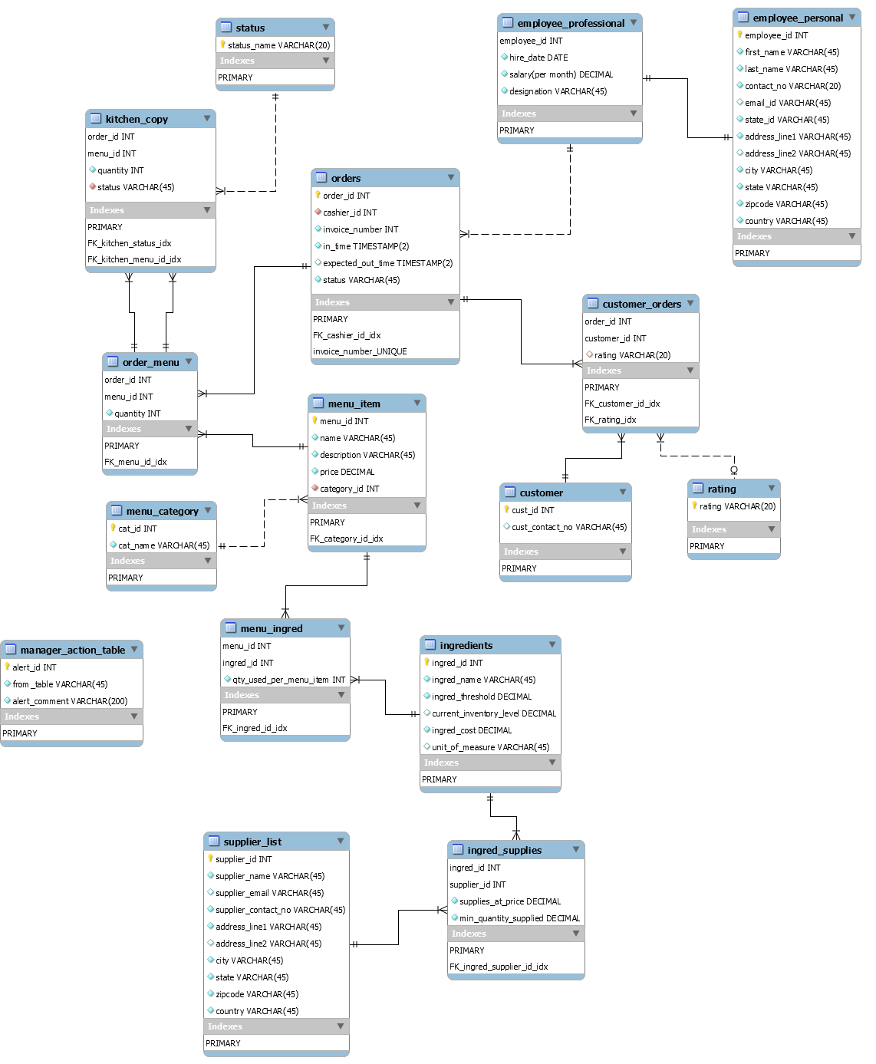

Note: Many-to-many relationships have been implemented using a third (bridge) table.

**VIEWS Implemented**

* View Definition 1:

We can calculate the total value of each order quickly using this view.

Using the “in_time” field, we can find the number of orders/value of orders processed per day or at any given time of day.

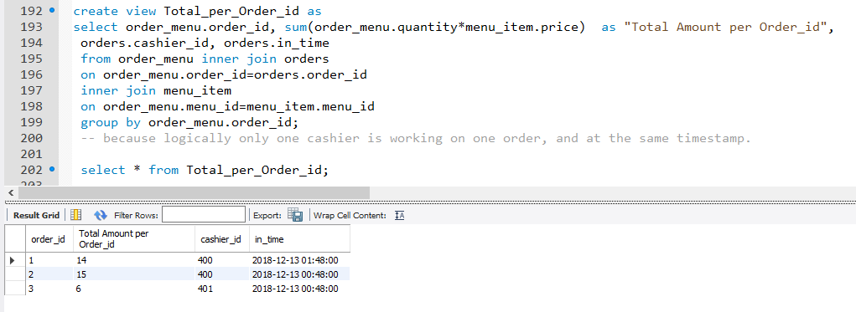

* View Definition 2:

We can calculate total value of orders placed by each customer. This can help us determine the average sales per customer.

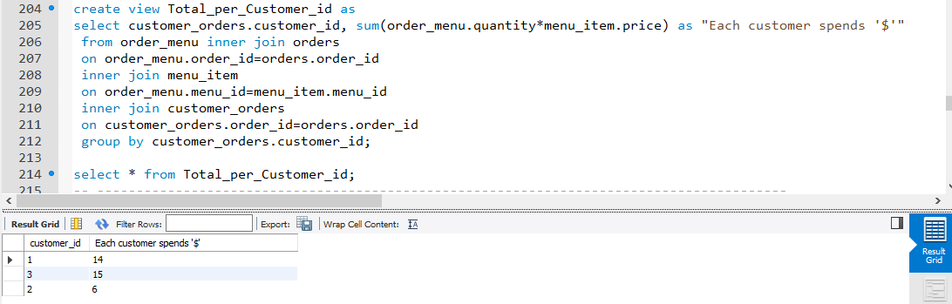

**TRIGGERS Implemented**

* Two triggers on same table to generate column data:

MYSQL does not allow two fields to be set to “auto_increment” in the same table. But I needed two fields to be auto-generated. So a trigger “invoice_id_generator” has been used to generate the second field “invoice_number”.

A field was needed that specified a timeout situation that was 30 minutes from when data is inserted. (30 minutes since order was placed.) Hence another trigger “Out_time_generator” has been used to document that time.

“PRECEDES” keyword is used to denote that trigger “invoice_id_generator” precedes trigger “Out_time_generator”.

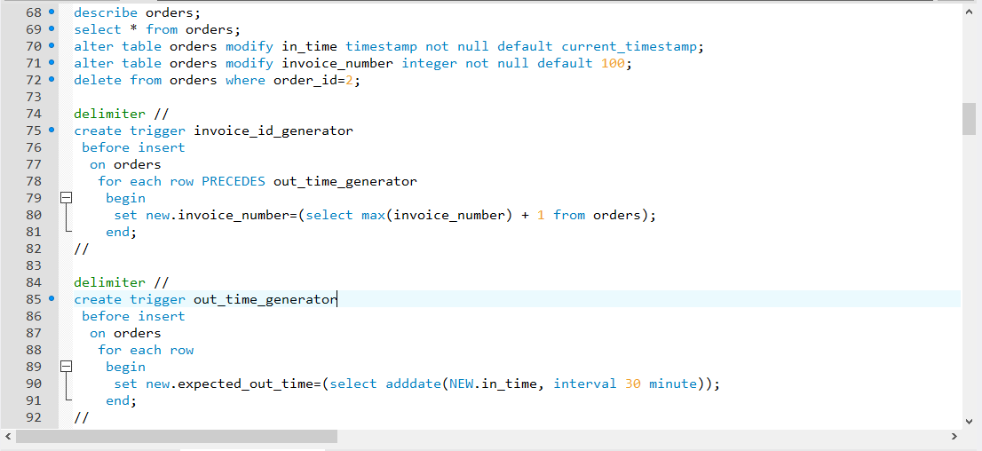

* Trigger to Insert data in ‘Manager_action_table’ (to alert manager) when inventory quantity goes below threshold value:

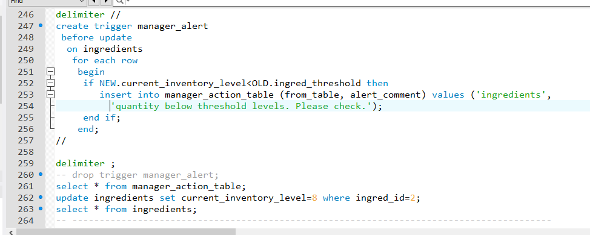

* Trigger to populate “kitchen_copy” table to reduce manual work:

“kitchen_copy” is the kitchen’s copy of the order that has to be fulfilled. Instead of manually entering data, trigger “populate_kitchen_copy” inserts a statement in the table each time a row is inserted in table “order_menu”.

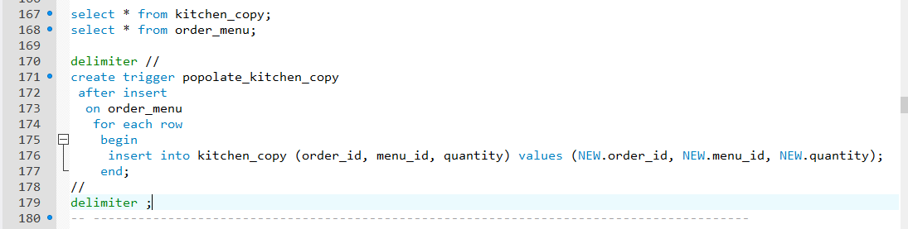

**CHECKS Implemented using Another Table**

As we know, MySQL does not support check constraints. As a workaround, another table can be used to limit the values of a column.

* Rating table.

“rating” field of “customer_orders” can only have values that are already present in “rating” table.

This is possible due to referential integrity.

Referenced table: “rating” (PK)

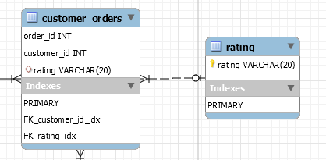

* Status table.

“status” field of “kitchen_copy” table can only have values that are present in “status” table.

This is possible due to referential integrity.

Referenced table: “status” (PK)

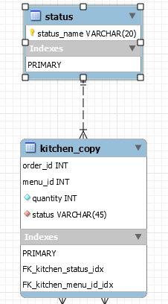

Appendix A: MySQL Dump

CREATE DATABASE IF NOT EXISTS `dmdd_project_garima` /*!40100 DEFAULT CHARACTER SET utf8 */;

USE `dmdd_project_garima`;

-- MySQL dump 10.13 Distrib 8.0.12, for Win64 (x86_64)

--

-- Host: localhost Database: dmdd_project_garima

-- ------------------------------------------------------

-- Server version 8.0.12

/*!40101 SET @OLD_CHARACTER_SET_CLIENT=@@CHARACTER_SET_CLIENT */;

/*!40101 SET @OLD_CHARACTER_SET_RESULTS=@@CHARACTER_SET_RESULTS */;

/*!40101 SET @OLD_COLLATION_CONNECTION=@@COLLATION_CONNECTION */;

SET NAMES utf8 ;

/*!40103 SET @OLD_TIME_ZONE=@@TIME_ZONE */;

/*!40103 SET TIME_ZONE='+00:00' */;

/*!40014 SET @OLD_UNIQUE_CHECKS=@@UNIQUE_CHECKS, UNIQUE_CHECKS=0 */;

/*!40014 SET @OLD_FOREIGN_KEY_CHECKS=@@FOREIGN_KEY_CHECKS, FOREIGN_KEY_CHECKS=0 */;

/*!40101 SET @OLD_SQL_MODE=@@SQL_MODE, SQL_MODE='NO_AUTO_VALUE_ON_ZERO' */;

/*!40111 SET @OLD_SQL_NOTES=@@SQL_NOTES, SQL_NOTES=0 */;

--

-- Table structure for table `customer`

--

DROP TABLE IF EXISTS `customer`;

/*!40101 SET @saved_cs_client = @@character_set_client */;

SET character_set_client = utf8mb4 ;

CREATE TABLE `customer` (

`cust_id` int(11) NOT NULL,

`cust_contact_no` varchar(45) DEFAULT NULL,

PRIMARY KEY (`cust_id`)

) ENGINE=InnoDB DEFAULT CHARSET=utf8;

/*!40101 SET character_set_client = @saved_cs_client */;

--

-- Dumping data for table `customer`

--

LOCK TABLES `customer` WRITE;

/*!40000 ALTER TABLE `customer` DISABLE KEYS */;

INSERT INTO `customer` VALUES (1,'9858747895'),(2,NULL),(3,'5487965894'),(4,NULL),(5,NULL),(6,NULL);

/*!40000 ALTER TABLE `customer` ENABLE KEYS */;

UNLOCK TABLES;

--

-- Table structure for table `customer_orders`

--

DROP TABLE IF EXISTS `customer_orders`;

/*!40101 SET @saved_cs_client = @@character_set_client */;

SET character_set_client = utf8mb4 ;

CREATE TABLE `customer_orders` (

`order_id` int(11) NOT NULL,

`customer_id` int(11) NOT NULL,

`rating` varchar(20) DEFAULT NULL,

PRIMARY KEY (`order_id`,`customer_id`),

KEY `FK_customer_id_idx` (`customer_id`),

KEY `FK_rating_idx` (`rating`),

CONSTRAINT `FK_customer_id` FOREIGN KEY (`customer_id`) REFERENCES `customer` (`cust_id`),

CONSTRAINT `FK_customer_order_id` FOREIGN KEY (`order_id`) REFERENCES `orders` (`order_id`),

CONSTRAINT `FK_rating` FOREIGN KEY (`rating`) REFERENCES `rating` (`rating`)

) ENGINE=InnoDB DEFAULT CHARSET=utf8;

/*!40101 SET character_set_client = @saved_cs_client */;

--

-- Dumping data for table `customer_orders`

--

LOCK TABLES `customer_orders` WRITE;

/*!40000 ALTER TABLE `customer_orders` DISABLE KEYS */;

INSERT INTO `customer_orders` VALUES (2,3,'average'),(1,1,'good'),(4,5,'poor'),(3,2,'recommend');

/*!40000 ALTER TABLE `customer_orders` ENABLE KEYS */;

UNLOCK TABLES;

--

-- Table structure for table `employee_personal`

--

DROP TABLE IF EXISTS `employee_personal`;

/*!40101 SET @saved_cs_client = @@character_set_client */;

SET character_set_client = utf8mb4 ;

CREATE TABLE `employee_personal` (

`employee_id` int(11) NOT NULL,

`first_name` varchar(45) NOT NULL,

`last_name` varchar(45) NOT NULL,

`contact_no` varchar(20) NOT NULL,

`email_id` varchar(45) DEFAULT NULL,

`state_id` varchar(45) NOT NULL,

`address_line1` varchar(45) NOT NULL,

`address_line2` varchar(45) DEFAULT NULL,

`city` varchar(45) NOT NULL,

`state` varchar(45) NOT NULL,

`zipcode` varchar(45) NOT NULL,

`country` varchar(45) NOT NULL,

PRIMARY KEY (`employee_id`)

) ENGINE=InnoDB DEFAULT CHARSET=utf8;

/*!40101 SET character_set_client = @saved_cs_client */;

--

-- Dumping data for table `employee_personal`

--

LOCK TABLES `employee_personal` WRITE;

/*!40000 ALTER TABLE `employee_personal` DISABLE KEYS */;

INSERT INTO `employee_personal` VALUES (100,'Katie','Smith','8574125036','123@gmail.com','MA12345','40, Main Road',NULL,'Townsville','State12','123456','USA'),(101,'Jenny','Jones','5748967875','jones@gmail.com','MA14876','22, Winding Road',NULL,'Big Town','State45','547857','USA'),(102,'Daisy','Moore','8527414569','Daisy@hotmail.com','TX25478','77, abc road','Apt 6','Small Village','State36','895748','USA'),(200,'Bob','Robson','8574126987','456@gmail.com','CA24578','12, Little Street',NULL,'Big City','Small State','254879','USA'),(300,'Sandra','Jakes','9875879654','sandra@her_mail.com','TX45874','25, Village Main',NULL,'Windy Village','Golden State','254785','USA'),(301,'John','Jones','8745896857','jj@jonesmail.org','MA15568','32, Main Road',NULL,'Townsville','Distant State','245875','USA'),(400,'Steve','Gee','2547898547','steve@gee.com','CA36598','45, Happy Lane',NULL,'Big Apple City','New State','478578','USA'),(401,'Nick','White','5787458796','white@house.com','NJ54875','3, Tiny Terrace','Apt 8','Big City','Small State','874589','USA');

/*!40000 ALTER TABLE `employee_personal` ENABLE KEYS */;

UNLOCK TABLES;

--

-- Table structure for table `employee_professional`

--

DROP TABLE IF EXISTS `employee_professional`;

/*!40101 SET @saved_cs_client = @@character_set_client */;

SET character_set_client = utf8mb4 ;

CREATE TABLE `employee_professional` (

`employee_id` int(11) NOT NULL,

`hire_date` date NOT NULL,

`salary(per month)` float NOT NULL,

`designation` varchar(45) NOT NULL,

PRIMARY KEY (`employee_id`),

CONSTRAINT `FK_employee_id` FOREIGN KEY (`employee_id`) REFERENCES `employee_personal` (`employee_id`) ON UPDATE CASCADE

) ENGINE=InnoDB DEFAULT CHARSET=utf8;

/*!40101 SET character_set_client = @saved_cs_client */;

--

-- Dumping data for table `employee_professional`

--

LOCK TABLES `employee_professional` WRITE;

/*!40000 ALTER TABLE `employee_professional` DISABLE KEYS */;

INSERT INTO `employee_professional` VALUES (100,'2018-02-16',1000,'Cook'),(101,'2016-04-23',1000,'Cook'),(102,'2016-05-30',1000,'Cook'),(200,'2015-05-22',3700,'Manager'),(300,'2016-08-04',700,'Server'),(301,'2017-06-29',700,'Server'),(400,'2017-06-24',1000,'Cashier'),(401,'2016-12-03',1000,'Cashier');

/*!40000 ALTER TABLE `employee_professional` ENABLE KEYS */;

UNLOCK TABLES;

--

-- Table structure for table `ingred_supplies`

--

DROP TABLE IF EXISTS `ingred_supplies`;

/*!40101 SET @saved_cs_client = @@character_set_client */;

SET character_set_client = utf8mb4 ;

CREATE TABLE `ingred_supplies` (

`ingred_id` int(11) NOT NULL,

`supplier_id` int(11) NOT NULL,

`supplies_at_price` decimal(10,0) NOT NULL,

`min_quantity_supplied` decimal(10,0) NOT NULL,

PRIMARY KEY (`ingred_id`,`supplier_id`),

KEY `FK_ingred_supplier_id_idx` (`supplier_id`),

CONSTRAINT `FK_ingred_supplier_id` FOREIGN KEY (`supplier_id`) REFERENCES `supplier_list` (`supplier_id`),

CONSTRAINT `FK_supp_ingred_id` FOREIGN KEY (`ingred_id`) REFERENCES `ingredients` (`ingred_id`)

) ENGINE=InnoDB DEFAULT CHARSET=utf8;

/*!40101 SET character_set_client = @saved_cs_client */;

--

-- Dumping data for table `ingred_supplies`

--

LOCK TABLES `ingred_supplies` WRITE;

/*!40000 ALTER TABLE `ingred_supplies` DISABLE KEYS */;

INSERT INTO `ingred_supplies` VALUES (1,1,18,100),(1,2,20,100),(2,1,4,5);

/*!40000 ALTER TABLE `ingred_supplies` ENABLE KEYS */;

UNLOCK TABLES;

--

-- Table structure for table `ingredients`

--

DROP TABLE IF EXISTS `ingredients`;

/*!40101 SET @saved_cs_client = @@character_set_client */;

SET character_set_client = utf8mb4 ;

CREATE TABLE `ingredients` (

`ingred_id` int(11) NOT NULL AUTO_INCREMENT,

`ingred_name` varchar(45) NOT NULL,

`ingred_threshold` decimal(10,0) NOT NULL,

`current_inventory_level` decimal(10,0) DEFAULT NULL,

`ingred_cost` decimal(10,0) NOT NULL,

`unit_of_measure` varchar(45) DEFAULT NULL,

PRIMARY KEY (`ingred_id`)

) ENGINE=InnoDB AUTO_INCREMENT=5 DEFAULT CHARSET=utf8;

/*!40101 SET character_set_client = @saved_cs_client */;

--

-- Dumping data for table `ingredients`

--

LOCK TABLES `ingredients` WRITE;

/*!40000 ALTER TABLE `ingredients` DISABLE KEYS */;

INSERT INTO `ingredients` VALUES (1,'peas',100,150,20,'boxes'),(2,'lemons',10,8,10,'pounds'),(3,'veg patty',300,350,10,'pieces'),(4,'ketchup',500,550,10,'sachets');

/*!40000 ALTER TABLE `ingredients` ENABLE KEYS */;

UNLOCK TABLES;

/*!50003 SET @saved_cs_client = @@character_set_client */ ;

/*!50003 SET @saved_cs_results = @@character_set_results */ ;

/*!50003 SET @saved_col_connection = @@collation_connection */ ;

/*!50003 SET character_set_client = utf8mb4 */ ;

/*!50003 SET character_set_results = utf8mb4 */ ;

/*!50003 SET collation_connection = utf8mb4_0900_ai_ci */ ;

/*!50003 SET @saved_sql_mode = @@sql_mode */ ;

/*!50003 SET sql_mode = 'STRICT_TRANS_TABLES,NO_ENGINE_SUBSTITUTION' */ ;

DELIMITER ;;

/*!50003 CREATE*/ /*!50017 DEFINER=`root`@`localhost`*/ /*!50003 TRIGGER `manager_alert` BEFORE UPDATE ON `ingredients` FOR EACH ROW begin

if NEW.current_inventory_level<OLD.ingred_threshold then

insert into manager_action_table (from_table, alert_comment) values ('ingredients','quantity below threshold levels. Please check.');

end if;

end */;;

DELIMITER ;

/*!50003 SET sql_mode = @saved_sql_mode */ ;

/*!50003 SET character_set_client = @saved_cs_client */ ;

/*!50003 SET character_set_results = @saved_cs_results */ ;

/*!50003 SET collation_connection = @saved_col_connection */ ;

--

-- Table structure for table `kitchen_copy`

--

DROP TABLE IF EXISTS `kitchen_copy`;

/*!40101 SET @saved_cs_client = @@character_set_client */;

SET character_set_client = utf8mb4 ;

CREATE TABLE `kitchen_copy` (

`order_id` int(11) NOT NULL,

`menu_id` int(11) NOT NULL,

`quantity` int(11) NOT NULL DEFAULT '0',

`status` varchar(45) NOT NULL DEFAULT 'Initial',

PRIMARY KEY (`order_id`,`menu_id`),

KEY `FK_kitchen_status_idx` (`status`),

KEY `FK_kitchen_menu_id_idx` (`menu_id`),

CONSTRAINT `FK_kitchen_menu_id` FOREIGN KEY (`menu_id`) REFERENCES `order_menu` (`menu_id`),

CONSTRAINT `FK_kitchen_order_id` FOREIGN KEY (`order_id`) REFERENCES `order_menu` (`order_id`),

CONSTRAINT `FK_kitchen_status` FOREIGN KEY (`status`) REFERENCES `status` (`status_name`) ON UPDATE CASCADE

) ENGINE=InnoDB DEFAULT CHARSET=utf8;

/*!40101 SET character_set_client = @saved_cs_client */;

--

-- Dumping data for table `kitchen_copy`

--

LOCK TABLES `kitchen_copy` WRITE;

/*!40000 ALTER TABLE `kitchen_copy` DISABLE KEYS */;

INSERT INTO `kitchen_copy` VALUES (3,5,1,'Initial');

/*!40000 ALTER TABLE `kitchen_copy` ENABLE KEYS */;

UNLOCK TABLES;

--

-- Table structure for table `manager_action_table`

--

DROP TABLE IF EXISTS `manager_action_table`;

/*!40101 SET @saved_cs_client = @@character_set_client */;

SET character_set_client = utf8mb4 ;

CREATE TABLE `manager_action_table` (

`alert_id` int(11) NOT NULL AUTO_INCREMENT,

`from_table` varchar(45) NOT NULL,

`alert_comment` varchar(200) NOT NULL,

PRIMARY KEY (`alert_id`)

) ENGINE=InnoDB AUTO_INCREMENT=2 DEFAULT CHARSET=utf8;

/*!40101 SET character_set_client = @saved_cs_client */;

--

-- Dumping data for table `manager_action_table`

--

LOCK TABLES `manager_action_table` WRITE;

/*!40000 ALTER TABLE `manager_action_table` DISABLE KEYS */;

INSERT INTO `manager_action_table` VALUES (1,'ingredients','quantity below threshold levels. Please check.');

/*!40000 ALTER TABLE `manager_action_table` ENABLE KEYS */;

UNLOCK TABLES;

--

-- Table structure for table `menu_category`

--

DROP TABLE IF EXISTS `menu_category`;

/*!40101 SET @saved_cs_client = @@character_set_client */;

SET character_set_client = utf8mb4 ;

CREATE TABLE `menu_category` (

`cat_id` int(11) NOT NULL,

`cat_name` varchar(45) NOT NULL,

PRIMARY KEY (`cat_id`)

) ENGINE=InnoDB DEFAULT CHARSET=utf8;

/*!40101 SET character_set_client = @saved_cs_client */;

--

-- Dumping data for table `menu_category`

--

LOCK TABLES `menu_category` WRITE;

/*!40000 ALTER TABLE `menu_category` DISABLE KEYS */;

INSERT INTO `menu_category` VALUES (1,'burgers'),(2,'fries'),(3,'sides'),(4,'beverages'),(5,'dessert');

/*!40000 ALTER TABLE `menu_category` ENABLE KEYS */;

UNLOCK TABLES;

--

-- Table structure for table `menu_ingred`

--

DROP TABLE IF EXISTS `menu_ingred`;

/*!40101 SET @saved_cs_client = @@character_set_client */;

SET character_set_client = utf8mb4 ;

CREATE TABLE `menu_ingred` (

`menu_id` int(11) NOT NULL,

`ingred_id` int(11) NOT NULL,

`qty_used_per_menu_item` int(11) NOT NULL,

PRIMARY KEY (`menu_id`,`ingred_id`),

KEY `FK_ingred_id_idx` (`ingred_id`),

CONSTRAINT `FK_ingred_id` FOREIGN KEY (`ingred_id`) REFERENCES `ingredients` (`ingred_id`),

CONSTRAINT `FK_menu_item_id` FOREIGN KEY (`menu_id`) REFERENCES `menu_item` (`menu_id`)

) ENGINE=InnoDB DEFAULT CHARSET=utf8;

/*!40101 SET character_set_client = @saved_cs_client */;

--

-- Dumping data for table `menu_ingred`

--

LOCK TABLES `menu_ingred` WRITE;

/*!40000 ALTER TABLE `menu_ingred` DISABLE KEYS */;

INSERT INTO `menu_ingred` VALUES (1,1,1),(1,3,1),(1,4,1),(2,1,1),(2,2,2),(2,4,1);

/*!40000 ALTER TABLE `menu_ingred` ENABLE KEYS */;

UNLOCK TABLES;

--

-- Table structure for table `menu_item`

--

DROP TABLE IF EXISTS `menu_item`;

/*!40101 SET @saved_cs_client = @@character_set_client */;

SET character_set_client = utf8mb4 ;

CREATE TABLE `menu_item` (

`menu_id` int(11) NOT NULL AUTO_INCREMENT,

`name` varchar(45) NOT NULL,

`description` varchar(45) NOT NULL,

`price` float NOT NULL,

`category_id` int(11) NOT NULL,

PRIMARY KEY (`menu_id`),

KEY `FK_category_id_idx` (`category_id`),

CONSTRAINT `FK_category_id` FOREIGN KEY (`category_id`) REFERENCES `menu_category` (`cat_id`) ON UPDATE CASCADE

) ENGINE=InnoDB AUTO_INCREMENT=10 DEFAULT CHARSET=utf8;

/*!40101 SET character_set_client = @saved_cs_client */;

--

-- Dumping data for table `menu_item`

--

LOCK TABLES `menu_item` WRITE;

/*!40000 ALTER TABLE `menu_item` DISABLE KEYS */;

INSERT INTO `menu_item` VALUES (1,'veg burger','totally veg',4,1),(2,'chicken burger','contains non vegetarian elements',6,1),(3,'fries','totally veg',4,2),(4,'garlic bread','vegatarian',3,3),(5,'cheese sticks','mozzarella filling',6,3),(6,'cocacola','beverage',2,4),(7,'pastry','lots of calories!',5,5);

/*!40000 ALTER TABLE `menu_item` ENABLE KEYS */;

UNLOCK TABLES;

--

-- Table structure for table `order_menu`

--

DROP TABLE IF EXISTS `order_menu`;

/*!40101 SET @saved_cs_client = @@character_set_client */;

SET character_set_client = utf8mb4 ;

CREATE TABLE `order_menu` (

`order_id` int(11) NOT NULL,

`menu_id` int(11) NOT NULL,

`quantity` int(11) NOT NULL,

PRIMARY KEY (`order_id`,`menu_id`),

KEY `FK_menu_id_idx` (`menu_id`),

CONSTRAINT `FK_menu_id` FOREIGN KEY (`menu_id`) REFERENCES `menu_item` (`menu_id`),

CONSTRAINT `FK_order_id` FOREIGN KEY (`order_id`) REFERENCES `orders` (`order_id`)

) ENGINE=InnoDB DEFAULT CHARSET=utf8;

/*!40101 SET character_set_client = @saved_cs_client */;

--

-- Dumping data for table `order_menu`

--

LOCK TABLES `order_menu` WRITE;

/*!40000 ALTER TABLE `order_menu` DISABLE KEYS */;

INSERT INTO `order_menu` VALUES (1,1,1),(1,2,1),(1,6,2),(2,3,2),(2,4,1),(2,6,2),(3,5,1);

/*!40000 ALTER TABLE `order_menu` ENABLE KEYS */;

UNLOCK TABLES;

/*!50003 SET @saved_cs_client = @@character_set_client */ ;

/*!50003 SET @saved_cs_results = @@character_set_results */ ;

/*!50003 SET @saved_col_connection = @@collation_connection */ ;

/*!50003 SET character_set_client = utf8mb4 */ ;

/*!50003 SET character_set_results = utf8mb4 */ ;

/*!50003 SET collation_connection = utf8mb4_0900_ai_ci */ ;

/*!50003 SET @saved_sql_mode = @@sql_mode */ ;

/*!50003 SET sql_mode = 'STRICT_TRANS_TABLES,NO_ENGINE_SUBSTITUTION' */ ;

DELIMITER ;;

/*!50003 CREATE*/ /*!50017 DEFINER=`root`@`localhost`*/ /*!50003 TRIGGER `popolate_kitchen_copy` AFTER INSERT ON `order_menu` FOR EACH ROW begin

insert into kitchen_copy (order_id, menu_id, quantity) values (NEW.order_id, NEW.menu_id, NEW.quantity);

end */;;

DELIMITER ;

/*!50003 SET sql_mode = @saved_sql_mode */ ;

/*!50003 SET character_set_client = @saved_cs_client */ ;

/*!50003 SET character_set_results = @saved_cs_results */ ;

/*!50003 SET collation_connection = @saved_col_connection */ ;

--

-- Table structure for table `orders`

--

DROP TABLE IF EXISTS `orders`;

/*!40101 SET @saved_cs_client = @@character_set_client */;

SET character_set_client = utf8mb4 ;

CREATE TABLE `orders` (

`order_id` int(11) NOT NULL AUTO_INCREMENT,

`cashier_id` int(11) NOT NULL,

`invoice_number` int(11) NOT NULL DEFAULT '100',

`in_time` timestamp NOT NULL DEFAULT CURRENT_TIMESTAMP,

`expected_out_time` timestamp NULL DEFAULT NULL,

PRIMARY KEY (`order_id`),

UNIQUE KEY `invoice_number` (`invoice_number`),

KEY `FK_cashier_id_idx` (`cashier_id`),

CONSTRAINT `FK_cashier_id` FOREIGN KEY (`cashier_id`) REFERENCES `employee_professional` (`employee_id`)

) ENGINE=InnoDB AUTO_INCREMENT=9 DEFAULT CHARSET=utf8;

/*!40101 SET character_set_client = @saved_cs_client */;

--

-- Dumping data for table `orders`

--

LOCK TABLES `orders` WRITE;

/*!40000 ALTER TABLE `orders` DISABLE KEYS */;

INSERT INTO `orders` VALUES (1,400,105,'2018-12-13 06:48:00','2018-12-13 07:18:00.00'),(2,400,102,'2018-12-13 05:48:00','2018-12-13 06:18:00.00'),(3,401,100,'2018-12-13 05:48:00','2018-12-13 06:18:00.00'),(4,400,4,'2018-12-13 05:48:00','2018-12-13 06:18:00.00'),(5,400,101,'2018-12-13 05:48:00','2018-12-13 06:18:00.00'),(6,400,103,'2018-12-13 05:59:00','2018-12-13 06:29:00.00'),(7,400,104,'2018-12-13 05:59:00','2018-12-13 06:29:00.00'),(8,401,106,'2018-12-13 09:13:56','2018-12-13 09:43:56.00');

/*!40000 ALTER TABLE `orders` ENABLE KEYS */;

UNLOCK TABLES;

/*!50003 SET @saved_cs_client = @@character_set_client */ ;

/*!50003 SET @saved_cs_results = @@character_set_results */ ;

/*!50003 SET @saved_col_connection = @@collation_connection */ ;

/*!50003 SET character_set_client = utf8mb4 */ ;

/*!50003 SET character_set_results = utf8mb4 */ ;

/*!50003 SET collation_connection = utf8mb4_0900_ai_ci */ ;

/*!50003 SET @saved_sql_mode = @@sql_mode */ ;

/*!50003 SET sql_mode = 'STRICT_TRANS_TABLES,NO_ENGINE_SUBSTITUTION' */ ;

DELIMITER ;;

/*!50003 CREATE*/ /*!50017 DEFINER=`root`@`localhost`*/ /*!50003 TRIGGER `invoice_id_generator` BEFORE INSERT ON `orders` FOR EACH ROW begin

set new.invoice_number=(select max(invoice_number) + 1 from orders);

end */;;

DELIMITER ;

/*!50003 SET sql_mode = @saved_sql_mode */ ;

/*!50003 SET character_set_client = @saved_cs_client */ ;

/*!50003 SET character_set_results = @saved_cs_results */ ;

/*!50003 SET collation_connection = @saved_col_connection */ ;

/*!50003 SET @saved_cs_client = @@character_set_client */ ;

/*!50003 SET @saved_cs_results = @@character_set_results */ ;

/*!50003 SET @saved_col_connection = @@collation_connection */ ;

/*!50003 SET character_set_client = utf8mb4 */ ;

/*!50003 SET character_set_results = utf8mb4 */ ;

/*!50003 SET collation_connection = utf8mb4_0900_ai_ci */ ;

/*!50003 SET @saved_sql_mode = @@sql_mode */ ;

/*!50003 SET sql_mode = 'STRICT_TRANS_TABLES,NO_ENGINE_SUBSTITUTION' */ ;

DELIMITER ;;

/*!50003 CREATE*/ /*!50017 DEFINER=`root`@`localhost`*/ /*!50003 TRIGGER `out_time_generator` BEFORE INSERT ON `orders` FOR EACH ROW begin

set new.expected_out_time=(select adddate(NEW.in_time, interval 30 minute));

end */;;

DELIMITER ;

/*!50003 SET sql_mode = @saved_sql_mode */ ;

/*!50003 SET character_set_client = @saved_cs_client */ ;

/*!50003 SET character_set_results = @saved_cs_results */ ;

/*!50003 SET collation_connection = @saved_col_connection */ ;

--

-- Table structure for table `rating`

--

DROP TABLE IF EXISTS `rating`;

/*!40101 SET @saved_cs_client = @@character_set_client */;

SET character_set_client = utf8mb4 ;

CREATE TABLE `rating` (

`rating` varchar(20) NOT NULL,

PRIMARY KEY (`rating`),

UNIQUE KEY `rating_UNIQUE` (`rating`)

) ENGINE=InnoDB DEFAULT CHARSET=utf8;

/*!40101 SET character_set_client = @saved_cs_client */;

--

-- Dumping data for table `rating`

--

LOCK TABLES `rating` WRITE;

/*!40000 ALTER TABLE `rating` DISABLE KEYS */;

INSERT INTO `rating` VALUES ('average'),('good'),('poor'),('recommend');

/*!40000 ALTER TABLE `rating` ENABLE KEYS */;

UNLOCK TABLES;

--

-- Table structure for table `status`

--

DROP TABLE IF EXISTS `status`;

/*!40101 SET @saved_cs_client = @@character_set_client */;

SET character_set_client = utf8mb4 ;

CREATE TABLE `status` (

`status_name` varchar(20) NOT NULL,

PRIMARY KEY (`status_name`)

) ENGINE=InnoDB DEFAULT CHARSET=utf8;

/*!40101 SET character_set_client = @saved_cs_client */;

--

-- Dumping data for table `status`

--

LOCK TABLES `status` WRITE;

/*!40000 ALTER TABLE `status` DISABLE KEYS */;

INSERT INTO `status` VALUES ('Complete'),('Delivered'),('In progress'),('Initial');

/*!40000 ALTER TABLE `status` ENABLE KEYS */;

UNLOCK TABLES;

--

-- Table structure for table `supplier_list`

--

DROP TABLE IF EXISTS `supplier_list`;

/*!40101 SET @saved_cs_client = @@character_set_client */;

SET character_set_client = utf8mb4 ;

CREATE TABLE `supplier_list` (

`supplier_id` int(11) NOT NULL AUTO_INCREMENT,

`supplier_name` varchar(45) NOT NULL,

`supplier_email` varchar(45) DEFAULT NULL,

`supplier_contact_no` varchar(45) NOT NULL,

`address_line1` varchar(45) NOT NULL,

`address_line2` varchar(45) DEFAULT NULL,

`city` varchar(45) NOT NULL,

`state` varchar(45) NOT NULL,

`zipcode` varchar(45) NOT NULL,

`country` varchar(45) NOT NULL,

PRIMARY KEY (`supplier_id`)

) ENGINE=InnoDB AUTO_INCREMENT=3 DEFAULT CHARSET=utf8;

/*!40101 SET character_set_client = @saved_cs_client */;

--

-- Dumping data for table `supplier_list`

--

LOCK TABLES `supplier_list` WRITE;

/*!40000 ALTER TABLE `supplier_list` DISABLE KEYS */;

INSERT INTO `supplier_list` VALUES (1,'Bright Brothers','bright@gmail.com','2587459865','09, Kite Lane',NULL,'Boston','MA','245875','USA'),(2,'Spice Kings','king@hotmail.com','9874563248','34, Lengthy Lane','Apt 6','Malden','MA','658749','USA');

/*!40000 ALTER TABLE `supplier_list` ENABLE KEYS */;

UNLOCK TABLES;

--

-- Temporary view structure for view `total_per_customer_id`

--

DROP TABLE IF EXISTS `total_per_customer_id`;

/*!50001 DROP VIEW IF EXISTS `total_per_customer_id`*/;

SET @saved_cs_client = @@character_set_client;

SET character_set_client = utf8mb4;

/*!50001 CREATE VIEW `total_per_customer_id` AS SELECT

1 AS `customer_id`,

1 AS `Each customer spends '$'`*/;

SET character_set_client = @saved_cs_client;

--

-- Temporary view structure for view `total_per_order_id`

--

DROP TABLE IF EXISTS `total_per_order_id`;

/*!50001 DROP VIEW IF EXISTS `total_per_order_id`*/;

SET @saved_cs_client = @@character_set_client;

SET character_set_client = utf8mb4;

/*!50001 CREATE VIEW `total_per_order_id` AS SELECT

1 AS `order_id`,

1 AS `Total Amount per Order_id`,

1 AS `cashier_id`,

1 AS `in_time`*/;

SET character_set_client = @saved_cs_client;

--

-- Dumping events for database 'dmdd_project_garima'

--

--

-- Dumping routines for database 'dmdd_project_garima'

--

--

-- Final view structure for view `total_per_customer_id`

--

/*!50001 DROP VIEW IF EXISTS `total_per_customer_id`*/;

/*!50001 SET @saved_cs_client = @@character_set_client */;

/*!50001 SET @saved_cs_results = @@character_set_results */;

/*!50001 SET @saved_col_connection = @@collation_connection */;

/*!50001 SET character_set_client = utf8mb4 */;

/*!50001 SET character_set_results = utf8mb4 */;

/*!50001 SET collation_connection = utf8mb4_0900_ai_ci */;

/*!50001 CREATE ALGORITHM=UNDEFINED */

/*!50013 DEFINER=`root`@`localhost` SQL SECURITY DEFINER */

/*!50001 VIEW `total_per_customer_id` AS select `customer_orders`.`customer_id` AS `customer_id`,sum((`order_menu`.`quantity` * `menu_item`.`price`)) AS `Each customer spends '$'` from (((`order_menu` join `orders` on((`order_menu`.`order_id` = `orders`.`order_id`))) join `menu_item` on((`order_menu`.`menu_id` = `menu_item`.`menu_id`))) join `customer_orders` on((`customer_orders`.`order_id` = `orders`.`order_id`))) group by `customer_orders`.`customer_id` */;

/*!50001 SET character_set_client = @saved_cs_client */;

/*!50001 SET character_set_results = @saved_cs_results */;

/*!50001 SET collation_connection = @saved_col_connection */;

--

-- Final view structure for view `total_per_order_id`

--

/*!50001 DROP VIEW IF EXISTS `total_per_order_id`*/;

/*!50001 SET @saved_cs_client = @@character_set_client */;

/*!50001 SET @saved_cs_results = @@character_set_results */;

/*!50001 SET @saved_col_connection = @@collation_connection */;

/*!50001 SET character_set_client = utf8mb4 */;

/*!50001 SET character_set_results = utf8mb4 */;

/*!50001 SET collation_connection = utf8mb4_0900_ai_ci */;

/*!50001 CREATE ALGORITHM=UNDEFINED */

/*!50013 DEFINER=`root`@`localhost` SQL SECURITY DEFINER */

/*!50001 VIEW `total_per_order_id` AS select `order_menu`.`order_id` AS `order_id`,sum((`order_menu`.`quantity` * `menu_item`.`price`)) AS `Total Amount per Order_id`,`orders`.`cashier_id` AS `cashier_id`,`orders`.`in_time` AS `in_time` from ((`order_menu` join `orders` on((`order_menu`.`order_id` = `orders`.`order_id`))) join `menu_item` on((`order_menu`.`menu_id` = `menu_item`.`menu_id`))) group by `order_menu`.`order_id` */;

/*!50001 SET character_set_client = @saved_cs_client */;

/*!50001 SET character_set_results = @saved_cs_results */;

/*!50001 SET collation_connection = @saved_col_connection */;

/*!40103 SET TIME_ZONE=@OLD_TIME_ZONE */;

/*!40101 SET SQL_MODE=@OLD_SQL_MODE */;

/*!40014 SET FOREIGN_KEY_CHECKS=@OLD_FOREIGN_KEY_CHECKS */;

/*!40014 SET UNIQUE_CHECKS=@OLD_UNIQUE_CHECKS */;

/*!40101 SET CHARACTER_SET_CLIENT=@OLD_CHARACTER_SET_CLIENT */;

/*!40101 SET CHARACTER_SET_RESULTS=@OLD_CHARACTER_SET_RESULTS */;

/*!40101 SET COLLATION_CONNECTION=@OLD_COLLATION_CONNECTION */;

/*!40111 SET SQL_NOTES=@OLD_SQL_NOTES */;

-- Dump completed on 2018-12-13 9:59:02